**A tutorial for using ScMile to run Milestoning simulations**

Here is an introduction of how we can use ScMile to run a milestoing simulation, and what we can expect from the script.

Before we start, let’s make sure you already have everything to run the script. Frist, we need a cluster and job schedulers PBS or Slurm to manage the submissions. Next, it is assumed that Python 3 is installed. If not, Anaconda is a good option, because it already includes all the libraries we need: Numpy, Pandas…etc. Anaconda can be downloaded from <https://www.anaconda.com/distribution/#download-section>, and the 3.X version is what we want. We also need NAMD 2.12+ along with COLVAR. It can be either CPU version of NAMD or GPU version, depending on your cluster. Last, we need to download the ScMile from <https://github.com/UTweiw/ScMiles>.

Ok. Let’s begin our first simulation with ScMile! We will start with a simple solvated Alanine Dipeptide simulation.

The alanine dipeptide is represented by a vector  that includes the coordinates of all the atoms in the system. The space of coarse variable is two dimensional and consists of the two dihedral angles  and . The structure of alanine dipeptide in the two corresponding minima illustrating the dihedral angles is shown in the figure below.

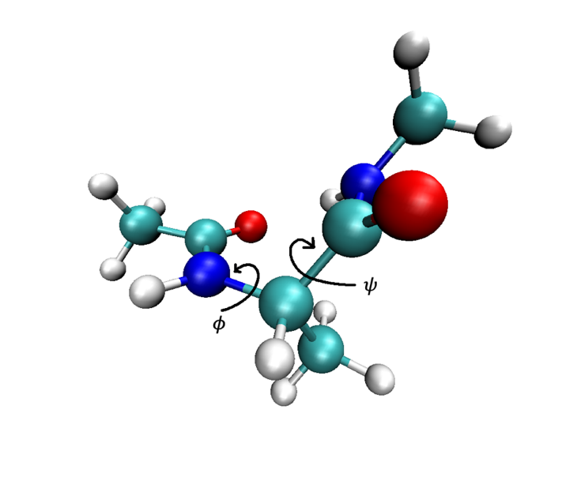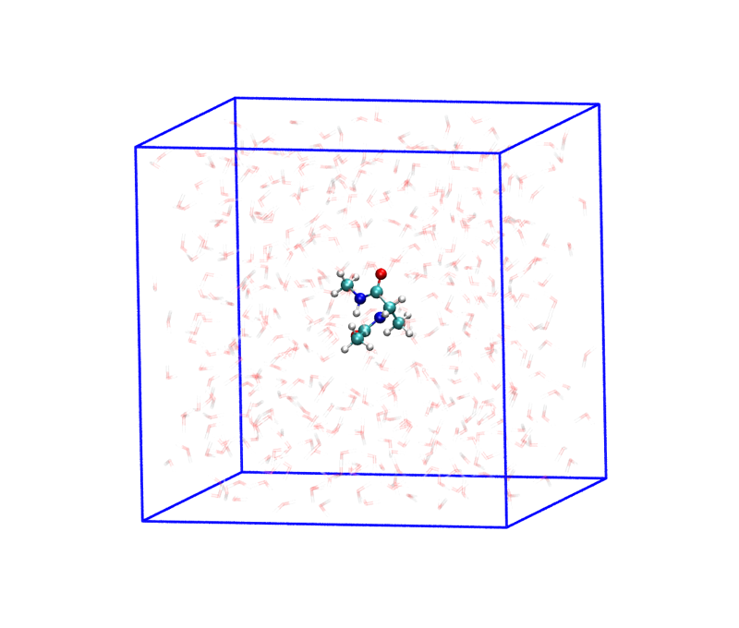

However, only the  dihedral angle is required to describe the conformational transition and the free energy landscape is considerably flatter. We plot twelve anchors as the red dots and the milestones as the horizontal black lines on the  map. The anchors are placed at $ψ=\left(-165+30s\right)°,s=0,1,2…11$. We consider the milestone between anchor 4 and anchor 5 as the reactant and the milestone between anchor 11 and anchor 12 as the product.

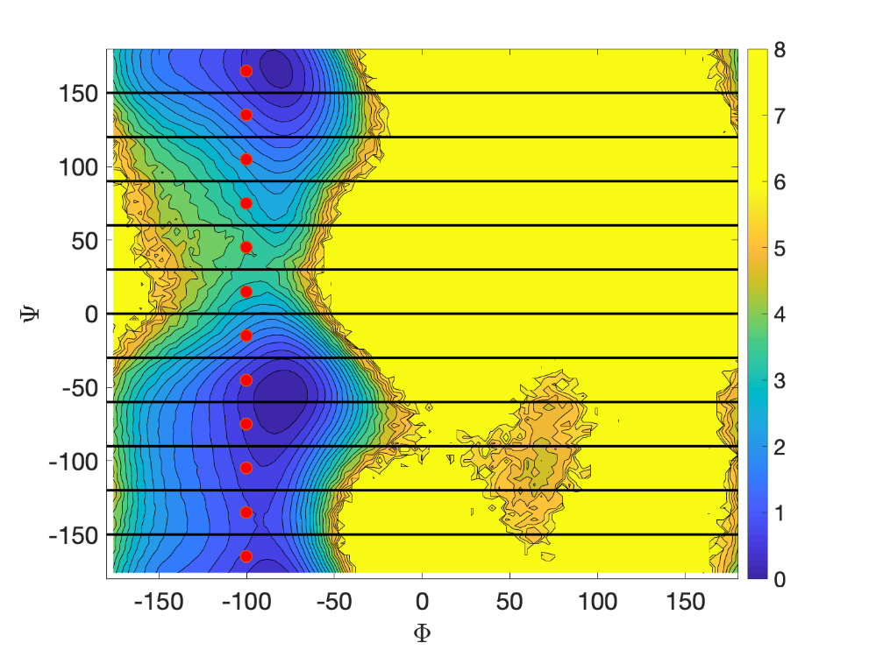

Similar to other MD simulations, we need the structure files for our system, i.e. Aladipep_sol.psf and Aladipep_sol.pdb. For Milestoning simulations, conformation information at each anchor is also required. Thus, we also have 12 pdb files, named as 1.pdb, 2.pdb …, for twelve anchors.

Once we have all the psf and pdb files, we can start to work on the script we just downloaded.

We first create a folder on the cluster and decompress ScMiles.zip to this folder. After decompression, there should be two subfolders: ScMiles and my_project_input. ScMiles contains all of the Python source code. my_project_input is where we need to have our input files. Right now there are 4 files in it. Input.txt is where we have all the inputs for ScMile. anchor.txt is where we will enter the anchor positions. Colvar.txt and custom.colvar are the colvar setup files. We will move to these files later. Inside my_project_input, a subfolder, example, has all the files we need for this tutorial. The folder structure is shown below. Note that we use colored blocks to represent folders and white blocks for files.

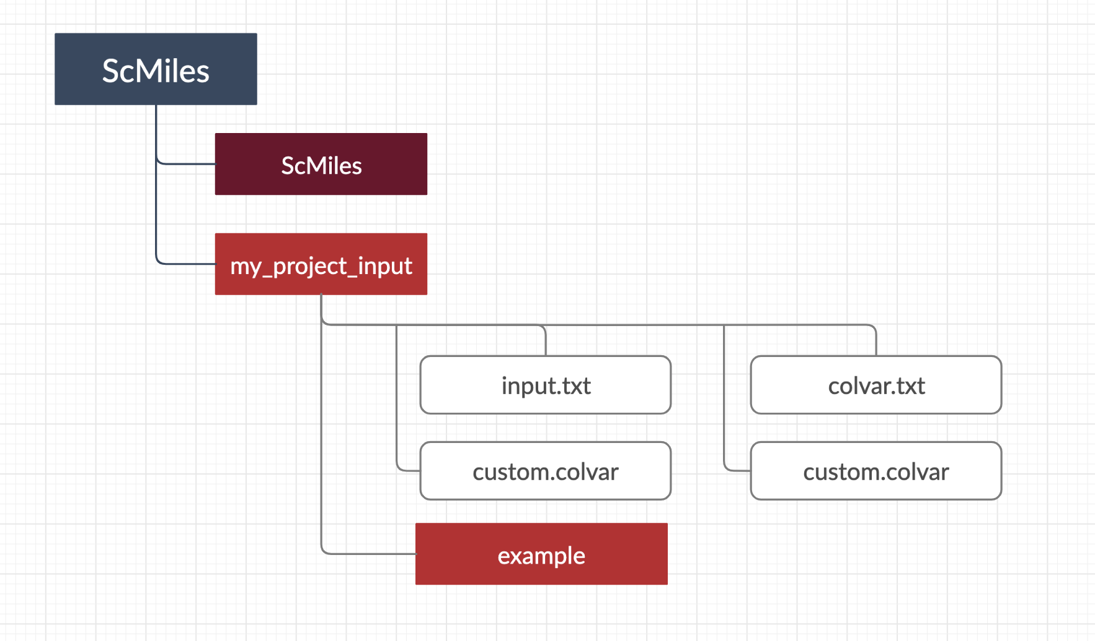

Let us now copy Aladipep_sol.psf and Aladipep_sol.pdb files to my_project_input. For anchor pdbs, we need to create a subfolder my_project_input/pdb, and copy 1.pdb, 2.pdb … here. We also copy all the parameter files (force fields) to my_project_input.

Now, the folder structure should look like this.

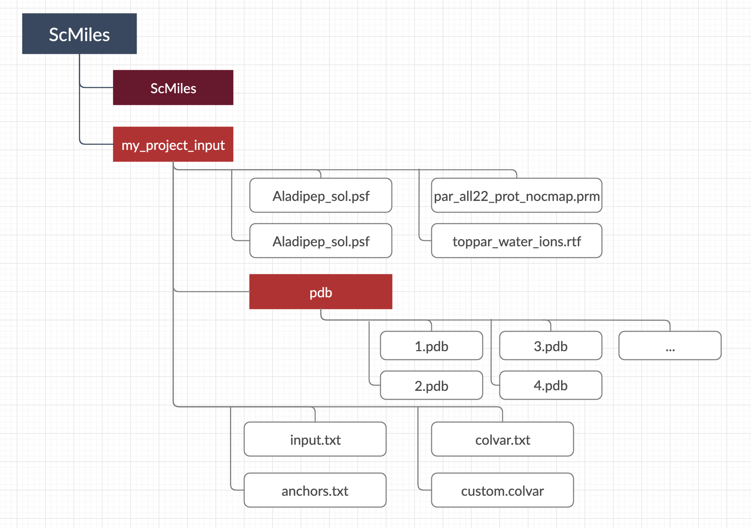

Open my_project_input/anchors.txt and type in the anchor position in coarse space. In this case, we only need to have the values for coarse variable $ψ$ at each milestone. Each line for one anchor. Note that the order of your anchors in this file should match the name of the anchor pdb files, i.e. the first line associates to 1.pdb, the second line associates to 2.pdb…etc.

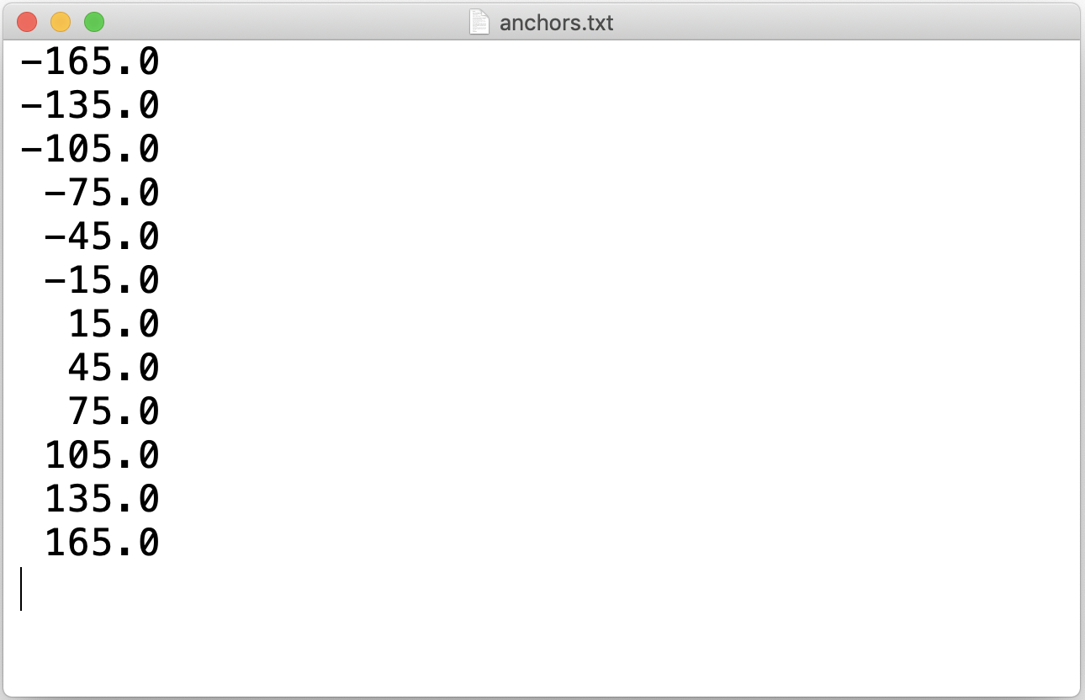

If you have more than one coarse variable for each anchor, you can have multiple values for one line.

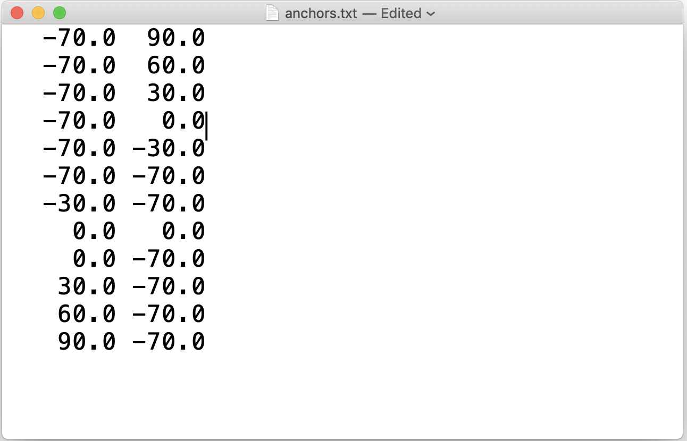

Next, we open my_project_input/input.txt. Most of the setups in ScMile is done here.

Starting the first option, **outputname** is the output name option in NAMD. In this tutorial, we use Aladipep.

**method** determines how you want to do your Milestoning: 0 for classic Milestoning and 1 for exact milestoning.

**max_iteration** is the maximum iteration number for exact milestoning. The script will stop if the maximum iteration number is reached, even the results is not converged yet.

**milestoneSearch** is how we define our milestones: 0 for Traverse and 1 for Seek. If Traverse is selected, it is assumed that there always exists a milestone between anchor i and anchor i+1, and it is only recommended for one-dimensional problems. In seek, we also need to have two additional setups, **initial_traj** and initial**_time**. We conduct **initial_traj** number of unbiased trajectories starting from each of the anchor, let them run for up to **initial_time** of time (in picosecond) and in the first time they hit another milestone we record the configuration. The discovery of this configuration activates the milestone between the two anchors and provide an initial configuration of sampling at the milestone. If Traverse is selected, the initial configuration of sampling is the conformation from one of the anchors associated to the milestone (e.g. 1.pdb for milestone between anchor 1 and anchor 2).

**total_trajs** is total number of initial configurations from sampling at each milestone. If you run 1 nanosecond for sampling and save restart files every 1 picosecond, you will have 1000 sets of restart files, which can be used as initial configurations for unbiased trajectories.

**start_traj** is the first configurations be used as the initial conformation for free trajectory. If Seek is used, even the very first configuration is close to the milestone, so you can use a small number for this option, say 1. However, if you use Traverse, it will take some time to reach the milestone because it started from anchor. Thus, you may want to use a large number here.

**traj_per_launch** is the number of free or unbiased trajectories each time to launch.

**interval** isthe interval between two configurations. For example, if interval is set to 10, free trajectories will use configurations number 1, 11, 21, 31…etc as initial conformations. If the restart files are written every picosecond, the configurations used are 1000.coor/vel/xsc, 11000.coor/vel/xsc, 21000.coor/vel/xsc…

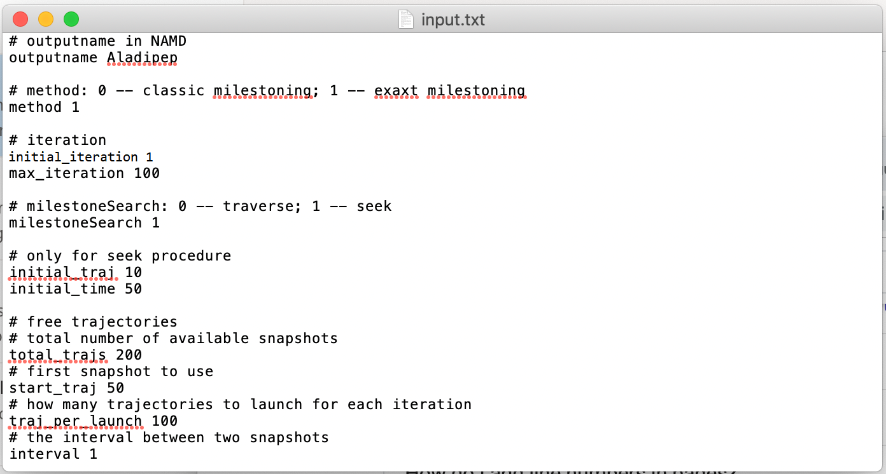

**customColvars**: “on" or “off” to indicate if any customized colvar exists. If it is set to “on”, the script will read custom.colvar file, and copy and paste everything in this file to the colvar configuration. Such colvar can be additional colvar module or just an index file. In this example, we want to have both of the coarse variables, $ϕ, ψ$, outputted all the time, so we choose “on”.

**custom_colvar**: the number of custom colvars in custom.colvar. Use 0 if no custom colvar module. Because we have two additional coarse variables, we have 2 here.

**colvarsTrajFrequency**: the frequency of each colvar are saved.

**colvarsRestartFrequency**: the frequency of each colvar are written to colvar.traj file.

**anchorsNum** is the total number of anchors. It will read the first **anchorsNum** of lines in anchor.txt and will only consider same number of the pdb files.

**reactant**: milestone(s) associated to the reactant state. Based on the setup in this example, we have reactant at milestone between anchor 4 and anchor 5.

**product**: similar to reactant. milestone(s) associated to the product state. Here we have milestone between anchor 11 and anchor 12.

If it is a multidimensional problem, the reactant and product state can be the cell number only. Use single integer to represent the cell number, and all the adjacent milestones will be marked as the reactant state.

**pbc**: milestones that associate to periodic boundary. In this example, we have +/- 180 degree as the periodic boundary, so we put 1,12 here.

**tolerance**: tolerance in MFPT convergence check (0.01 = 1%). If the difference of MFPT between last and current iteration is smaller than is number, the result is considered as converged, and the script will stop.

**jobsubmission**: command for job submission on HPC. (sbatch or qsub)

**jobcheck**: command for job check on HPC. (squeue or qstat)

**username**: your username on HPC

**seed*:*** random seed. Note that this is not the actual random seed used in NAMD. The seed used in NAMD will be a random number pulled based on the seed set in input.

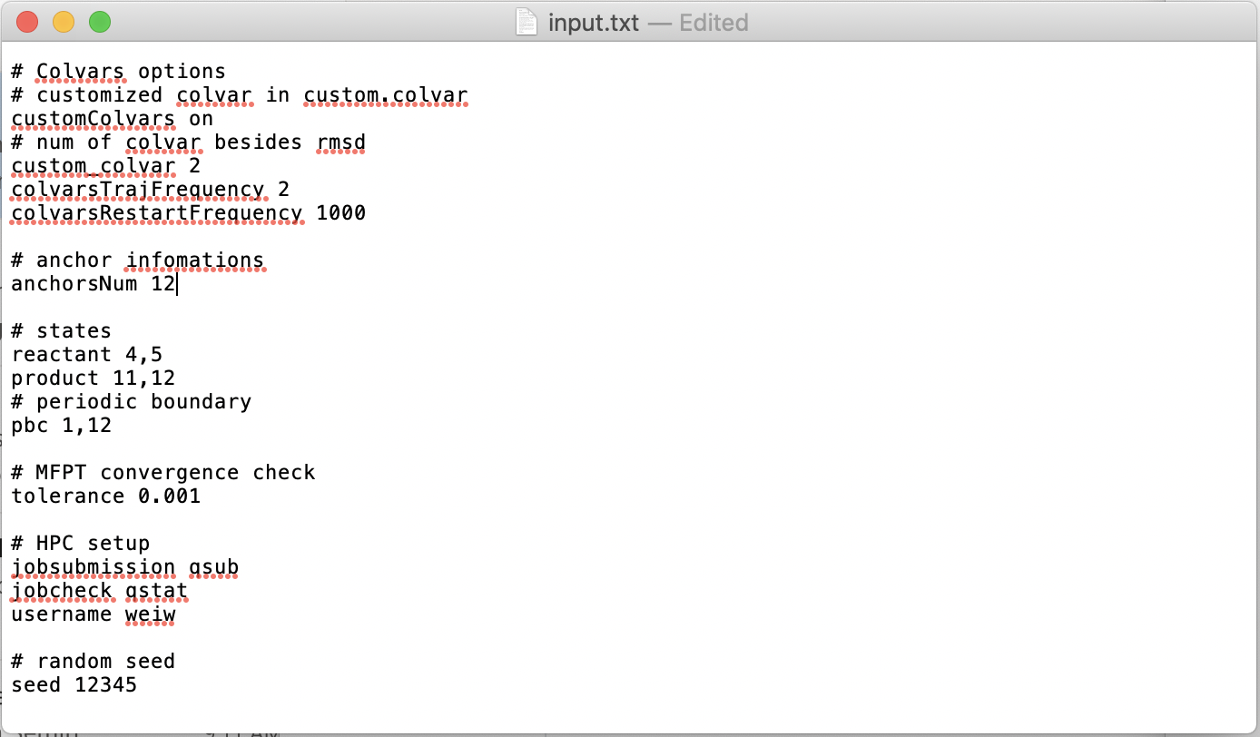

Ok. We have finished making changes in the input.txt. Let us take a look at Colvar. First, we open my_project_input/colvar.txt. In this file, we need to input two things: the coarse variable and the distance measurement. In this example, we only consider the dihedral angle $ψ$, so we have the colvar commands to define the dihedral angle, the distance measurement is a norm2 distance in coarse space. Because there is only one coarse variable, we choose the distance to each anchor as $abs\left(ψ-ψ_{i}\right)$, for $i=1,2,…12$. Use anchor.x as a bookkeeper for the coarse variable at anchor.

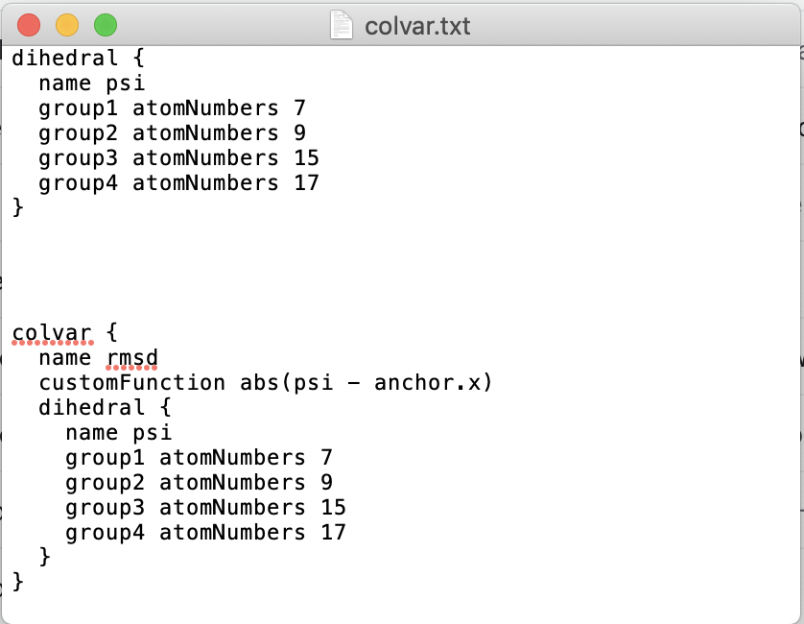

If you have more than one coarse variable, defining multiple colvars is also possible. However, only one distance measurement is allowed.

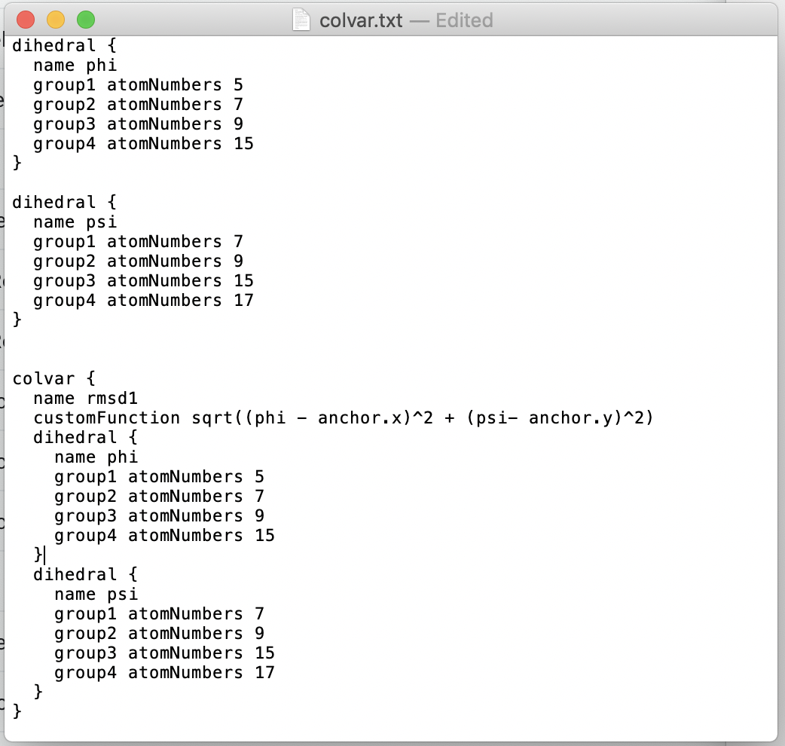

Note that the colvar here will not be outputted in the colvar.traj, because it is only used for constraining on the milestones. If you want to have them outputted, you can use customized colvar and turn on the custom_colvar in input.txt. In this example, we want to track the dihedral angles from time to time, we add these two coarse variables into custom_colvar, so that they can be shown in the colvar.traj files.

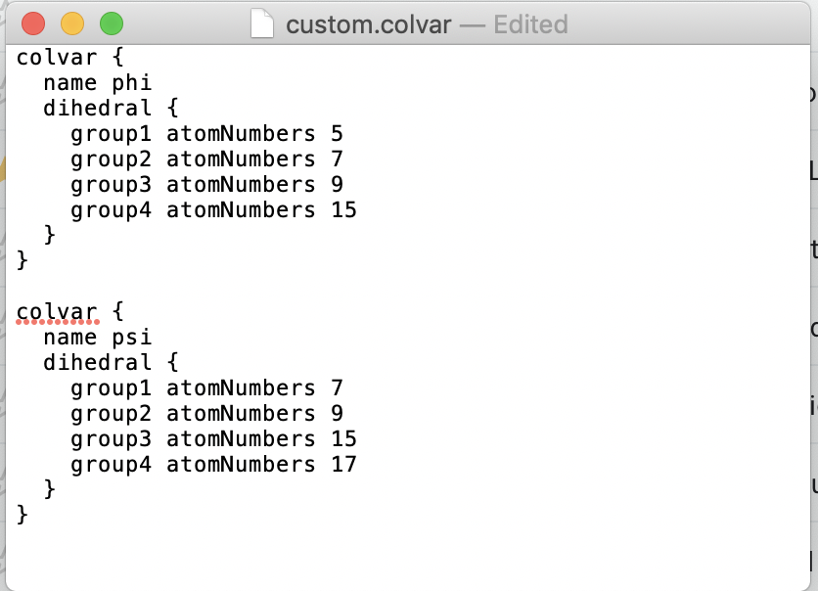

If you don’t need additional colvar, but for some reason want to have other commands for colvar (like the example below), you can have it in custom.colvar. If the custom.colvar has only commands but no colvar module, just turn on the customColvars and set custom_colvar to 0 in input.txt.

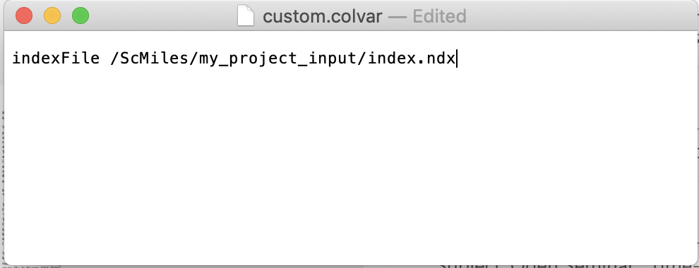

Since ScMile interfaces NAMD, next thing we are going to do is to setup NAMD configuration. We will need two NAMD configuration files, one for sampling process and one for un biased trajectories. Rename the one for sampling with sample.namd, and the one for free trajectories with free.namd, and move them to my_project_input. Such configurations vary by cases. For most of the cases, these two setups are slightly different. In the example here, we use NVT for sampling and NVE for unbiased trajectories. For some systems, you may have same setup for both. However, you still need to have two copies in your input folder.

Setup for NAMD is just like what you normally do for MD simulations. You specify the structure, parameters, force fields…etc. Here just do the same thing. However, a couple of things we need to keep in mind. 1) For all the parameters files, do use the absolute path instead of relevant path, so that the parameters can be accessed by all the jobs. 2) Have bincoordinates/ binvelocities/extendedSystem in free.namd, as a book keeper. ScMile will modify it and provide it with the correct file name. 3) save binary restart files. Remember that we use restart files as the initial configuration of the unbiased trajectories, so the total number restarts should match what you have for total_trajs in input.txt. For unbiased trajectories, the restart saving frequency can vary, but if you would like to use Exact Milestoning method, it is recommended to use a small number. Here we save restart files every 2 timesteps. Note that no matter what you choose for restartsave here, ScMiles will turn it off and only keep the most recent version.

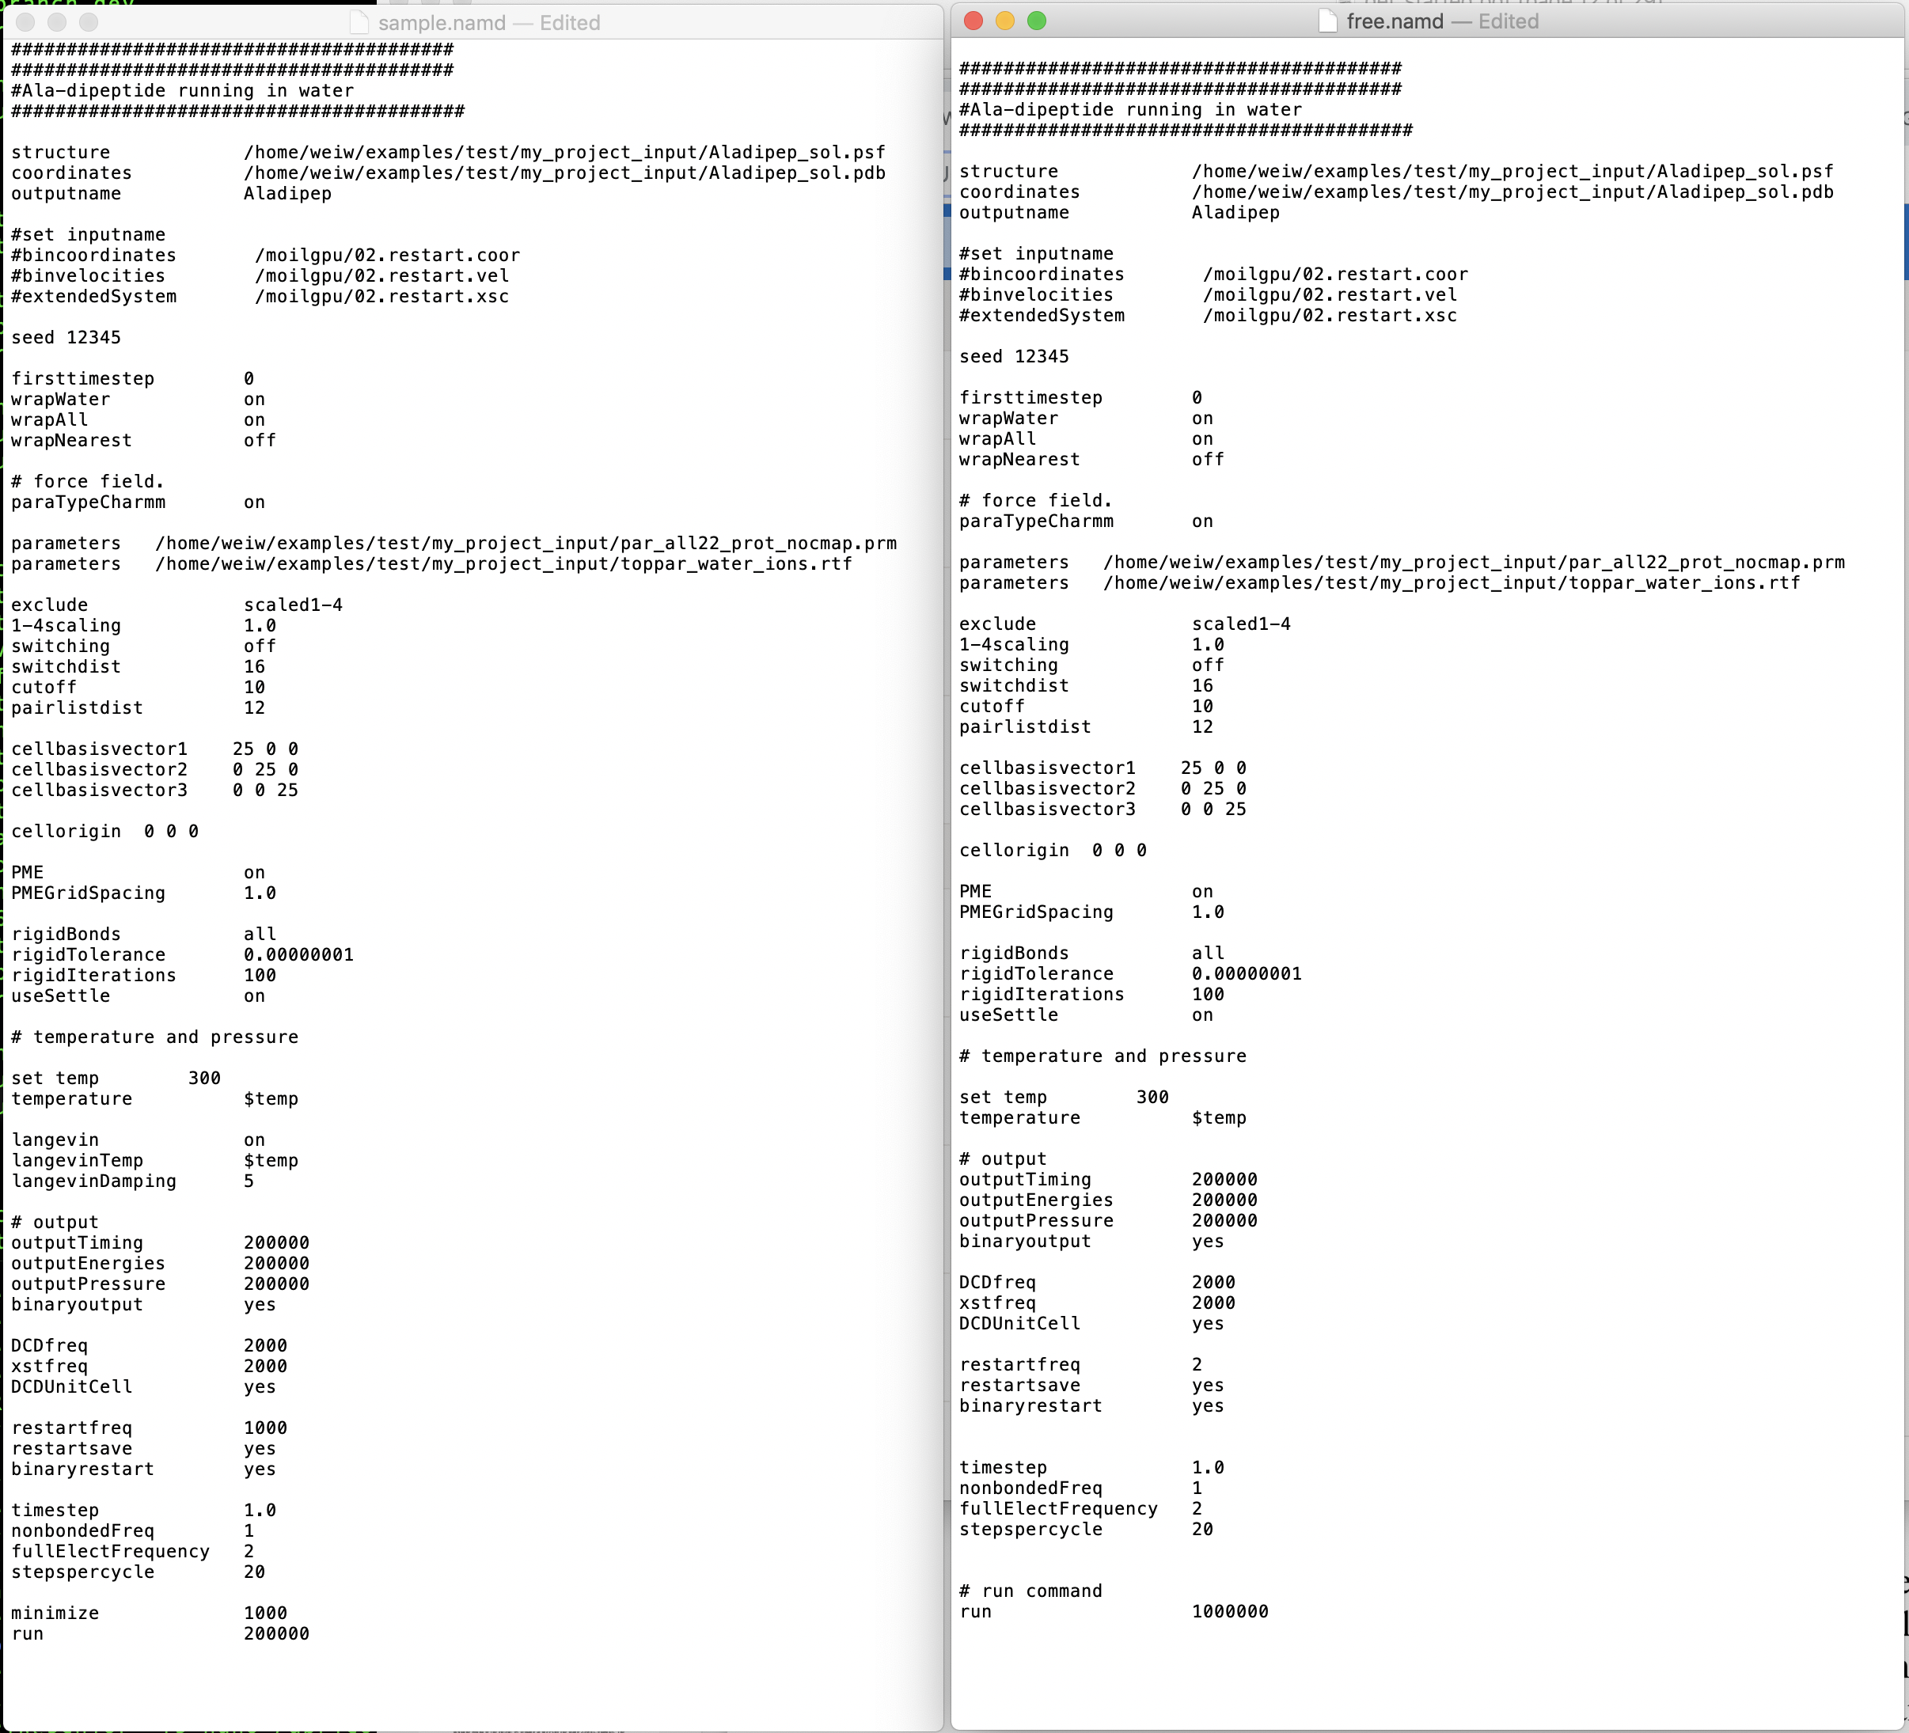

The last step before we can start the simulation is to tell ScMile how you would like to run on your cluster. Currently, a template bash script for job submission is necessary. It would be similar to what you use for other simulations. However, a couple of things need to be modified. First, use “name” as a place keeper to replace the real job name. Second, add a “cd path” command before call NAMD. This will help ScMile to locate the correct subfolder for each job. Third, use “namd” as a place keeper for the NAMD configuration file name. If you need to load additional module, you can do it as well. Again, just a regular submission file, but modify it with “name”, “cd path”, and “namd”. Simple examples for PBS and Slurm system are shown below. Copy it to my_project_input, and rename it as submit.

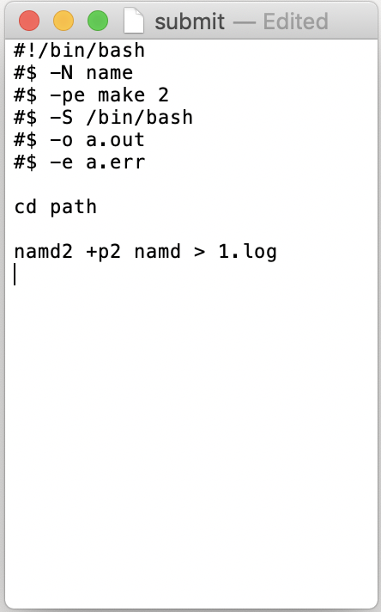 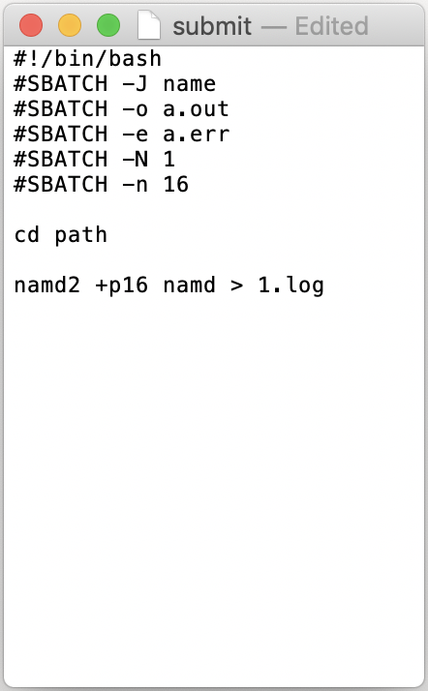

Finally, we have everything we need, and your folder should look like this.

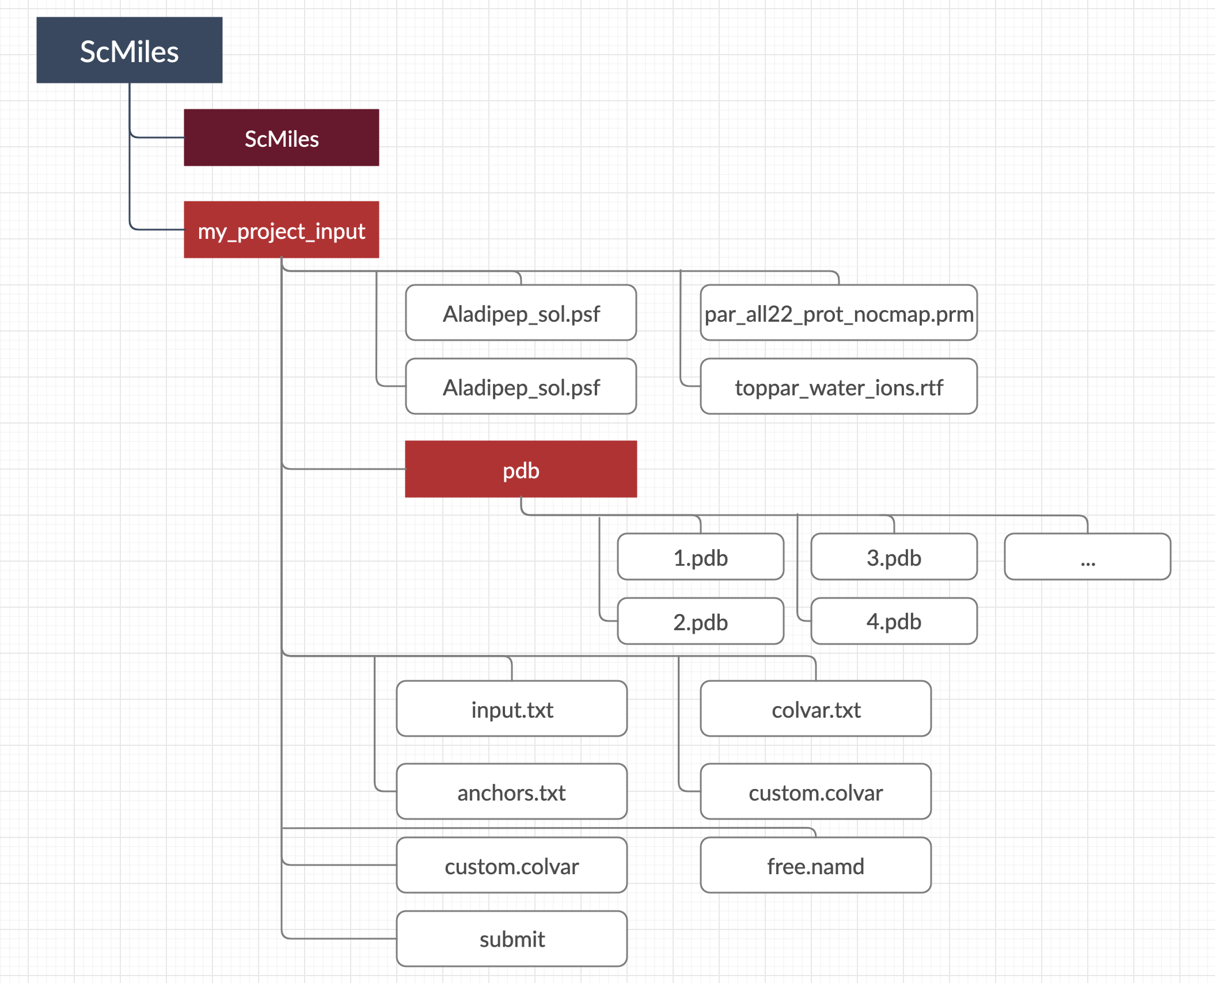

Now we can call ScMiles/main.py to start ScMile. If you have both Python 2 and Python 3 installed, make sure you use Python 3.

Once the simulation finished, the results can be found in my_project_output/, and label with iteration number and followed by time, i.e. my_project_output/1_2019-01-01 00:00:00. You can also find the most recent result in my_project_output/current folder. results.txt has most of the results. In this file, there are two sections. The first section has 6 columns showing the information for all the milestones. The first two columns represent the anchors associated with the milestone, i.e. (1, 2) means the milestone between anchor 1 and anchor 2. The third column is the flux for that milestone. The forth column shows the probability on the milestone. The last two columns show the free energy (in KbT) and the error bar for that milestone. The error calculation is based on 1000 samples generated with Beta random function. The second section in this file shows the MFPT. Two methods are used and the results should be similar.

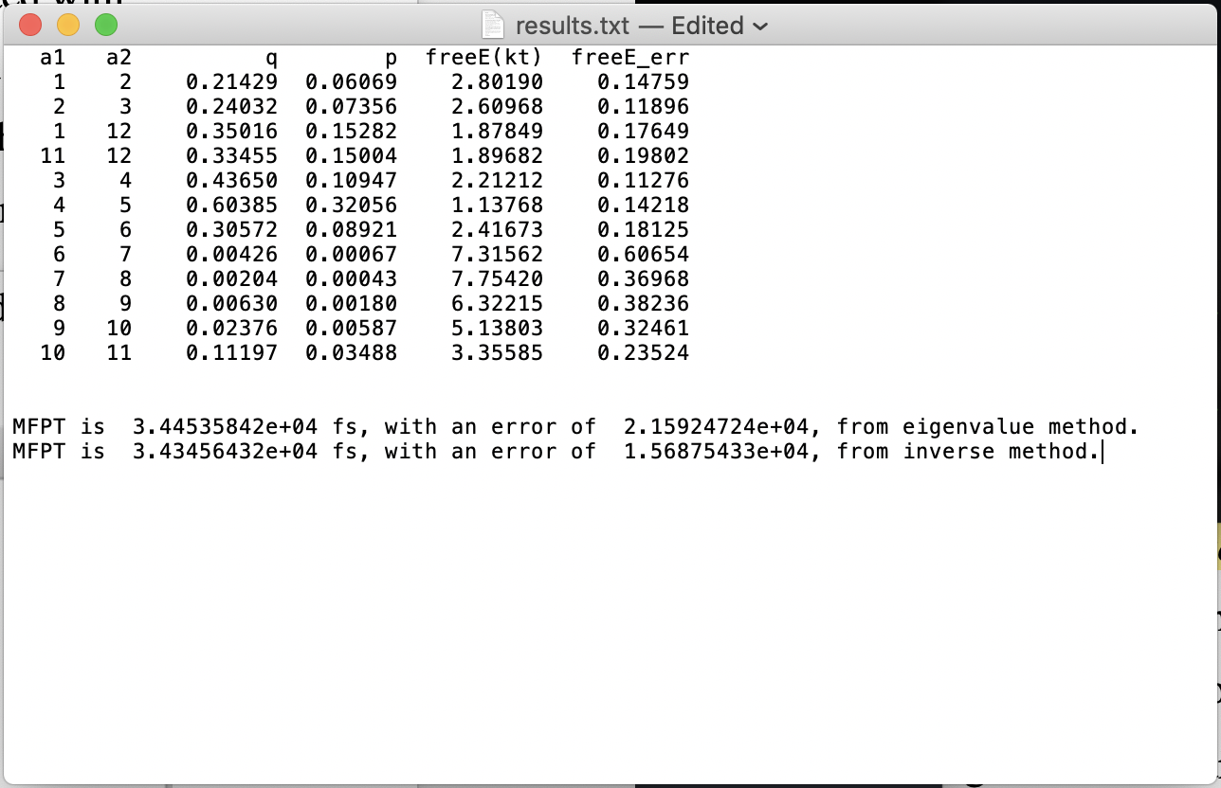

You can find the kernel matrix, K, in k.txt/k_norm.txt.

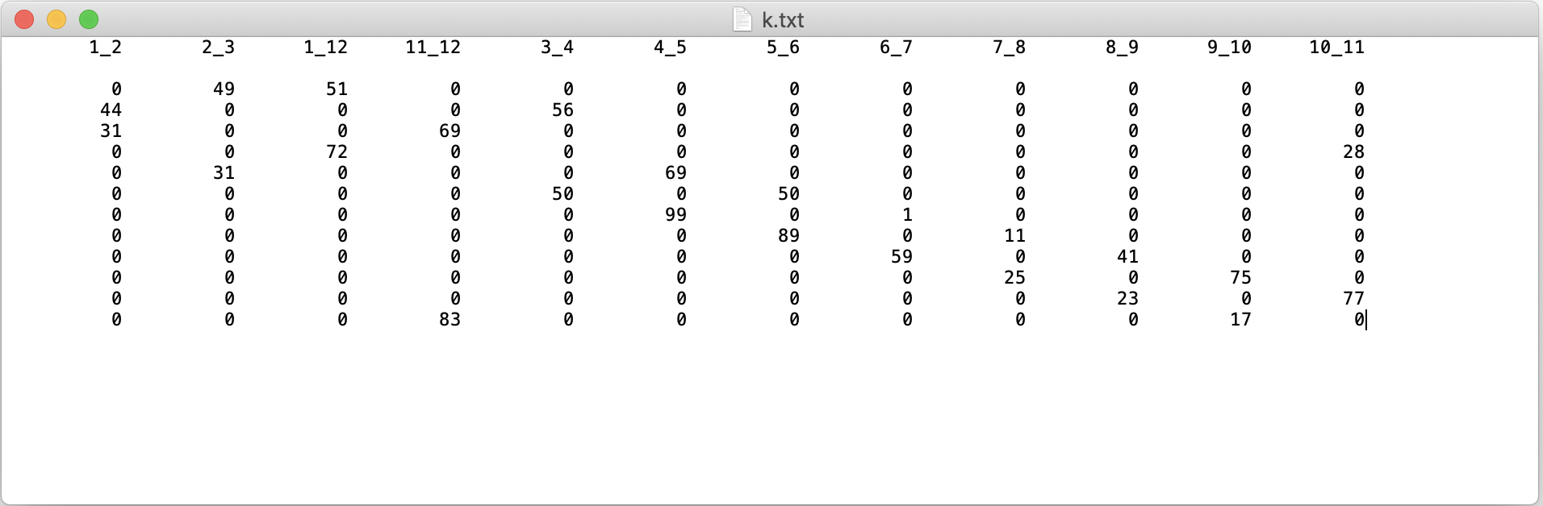

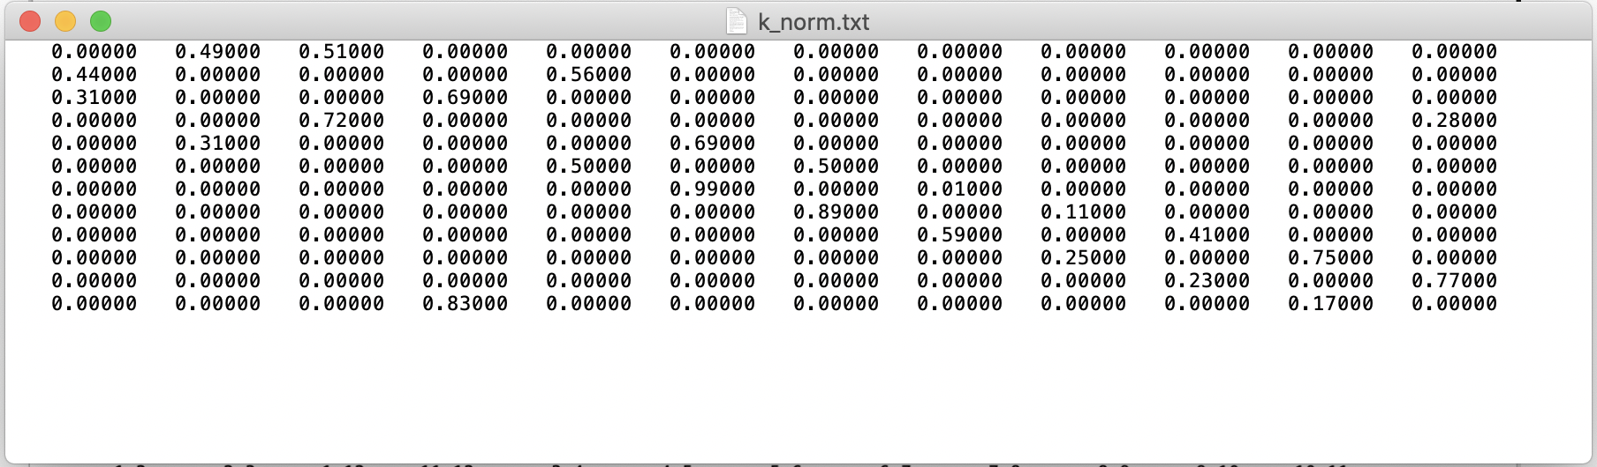

life_time.txt shows the lifetime information for each milestone and the standard deviation.

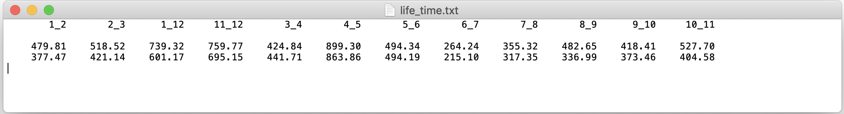

Committor.txt shows the committor function.



ms_index.npy is in Python numpy Dataform, saving the milestone index for analysis. log is the runtime log.

In crd folder, same level of my_project_output/, you can find all the sampling simulations and free trajectories. You can find subfolder labeled with milestone name: “1_2”, “2_3” ...etc. Each milestone folder has the trajectory for sampling simulation, and a subfolder “restarts” has all the restart files used as the initial conformation for unbiased simulations. In each milestone folder, you will see folders labeled with numbers. These are iteration numbers. If you chose Exact Milestoning method and it took 10 iterations to converge, you will see folders from 1 to 10, each has all the unbiased trajectories from this milestone. If you go even deeper, you will see all the trajectories, each has an induvial subfolder as well. Thus, if you want to check the 20th trajectory for milestone 1_2 at first iteration, you can go to crd/1_2/1/20.

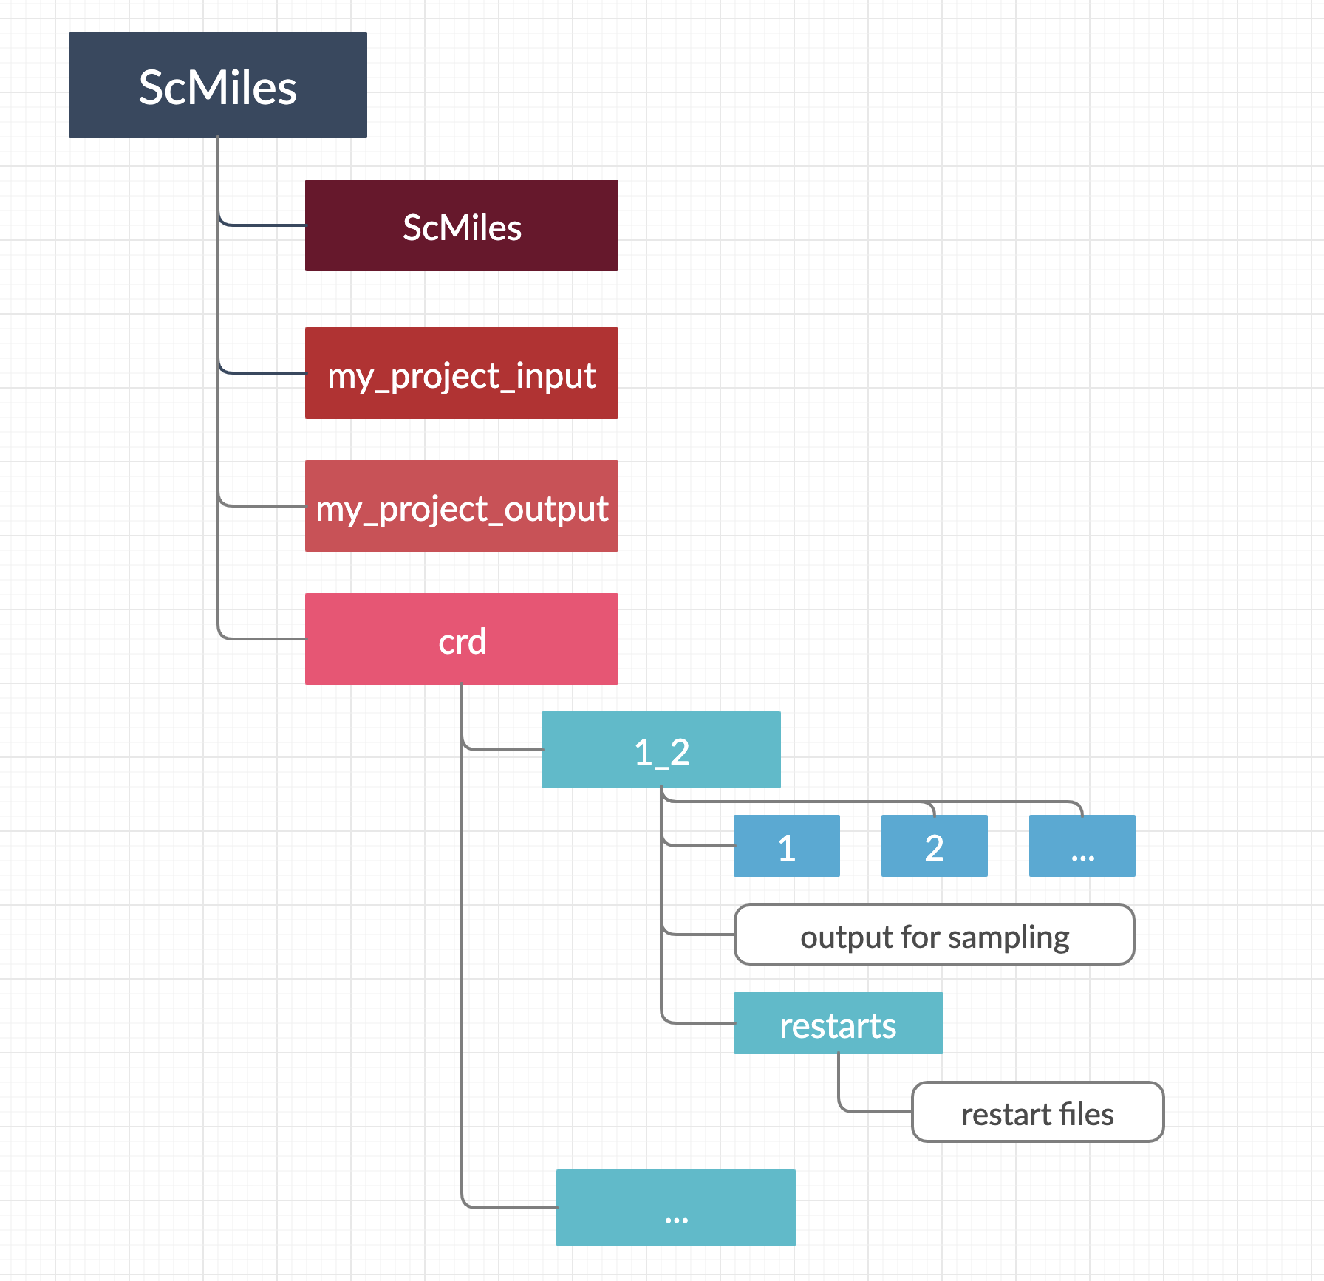

Additionally, for Exact Milestoning method, the distribution of unbiased simulations can be found in distribution in each milestone folder. It shows the weighting that the trajectory initially from each milestone at previous iteration will be adopted as the initial conformation for next iteration. Like the example below, at milestone 3_4, roughly half-half distribution should be considered. Thus, for the next iteration, 50 (out of 100) trajectories should be from milestone 2_3 at previous iteration, and 50 for milestone 4_5 as well. If there were only 10 trajectories reached milestone 3_4 from milestone 4_5 as previous iteration, 5 trajectories will be launched from each of those 10 configurations, with only 1 out of 5 keeps the same velocity while other 4 use new random velocities. This is the process of enrichment.

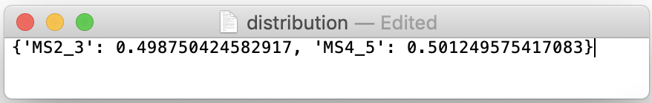

Enrichment information can be found under each iteration folder (starting from the second iteration). It counts the total number of trajectories introduced by enrichment at each milestone.

